At the end of the mobility, the evaluation questionnaire was developed online (Google Forms) and participants of the mobility were asked to fulfil the questionnaire.
For the students there were thirteen items for rating and two open answers. The participants students who had closer involvement with the project from all of the countries were asked to fulfill the questionnaire on paper besides to online form (10 from each country).
As for the teachers, 10 of them answered the questionnaire. It contained eight items for rating and three open answers.
Ranking Of Satisfaction With And Outcome Of The Mobility
As fort he students, results are:
To questions…
- "The online mobility met all my expectations":34,4 % Strongly agree, 34,4 % Agree 21,9 % Strongly disagree
- "The materials and presentations provided were helpful": 43,8 % Strongly agree , 34,4 % Agree, 12,5 % Strongly disagree
- "The knowledge from these workshops inspired me to do further research":40,6 % Strongly agree, 28,1% Agree, 18,8 % Neutral
- "The time for activities were sufficient":46,9 % Strongly agree. 28,1 % Agree
- "The knowledge I gained will be useful to me in the future":50 % Strongly agree, 31,3 Agree
- 46,9 % of the students answered “Strongly Agree” on the question "I was satisfied with the mobility overall".
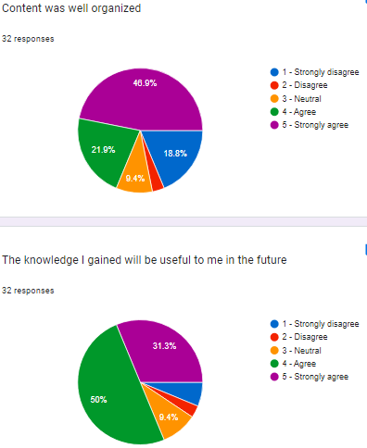
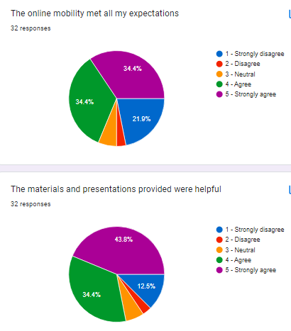
- 46,9 % of students found the content well organized.
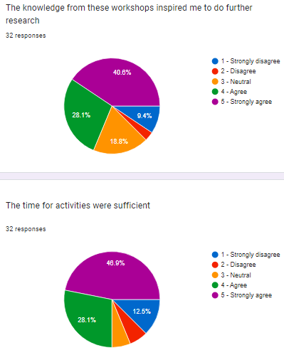

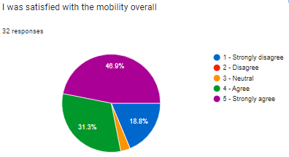

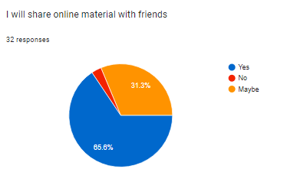
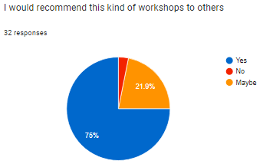
Students were asked whether, after this mobility, they would share online material ( 65,6 % Yes, 31,3 % Maybe) and the experiences gained with their friends (75 % Yes), as well as whether they would recommend this type of workshop to others (75 % Yes, 21,9 % Maybe).
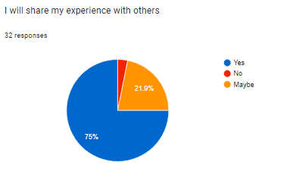

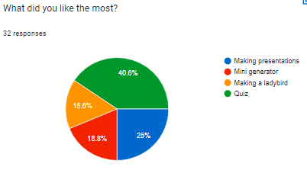
When we asked “What did you like the most?”, most of the students answered Quiz (40,6 %). Making presantation comes the second (25 %).

When we asked “Which workshop would you like to attend again?", most of them wanted "3D animals"(31,3 %) and “Making a ladybird” (21,9 %), while none of the students liked Origami moving animals.
About other workshops:
- Making presentations: 15,6 %
- Paper Wind roses/genrators: 15,6 %
- Drawing about benefits of windroses/genrators: 3,1 %
- Drawing/ painting wind roses/genrators. 12,5 %
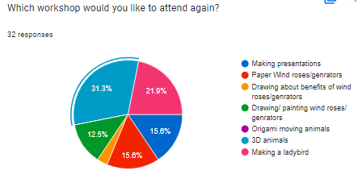

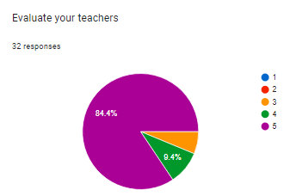
When they were asked to rate the teachers during these workshops, we got the following ratings:
5 – 84,4 %, 4 – 9,4 %, 3 – 6,3 % (We don’t have 1 and 2)

Besides the questions with the given categories, there are two questions for students:
- In the Praise / criticism section, we received 9 responses such as:
- Activities were educational
- It was enjoyable
- Activities were suficent
- Activities were educational
- Egiticiydi ve güzeldi
- Çok iyi ve egiticiydi
- :(
- 👍
- Everything is fine.
- Suggestions for improving workshops section, we received 3 written responses:
- No
- More drawings
- Does not have
As for the teachers, the results are:
To the questions "Was the plan and schedule clear?" and "Was there enough time to do all the activities planned by the coordinator of the mobility?", all 10 respondents answered in the affirmative.
To the question "Did unexpected problems occur during the mobility?" 4 teachers answered "No" and 6 of them answered "Yes". As an explanation for the unexpected problems, they indicated that different holiday time between the countries was a problem but we managed to overcome it successfully by using online tools and making little cahanges on the Schedule. The ineternet connection was one of the problem but we overcame it succesfully, too.
To the question “How well was the mobility organized?”, 7 teachers found the organization of the mobility perfect(5) while 2 teacher answered very well(4) and 1 teacher answered well(3).
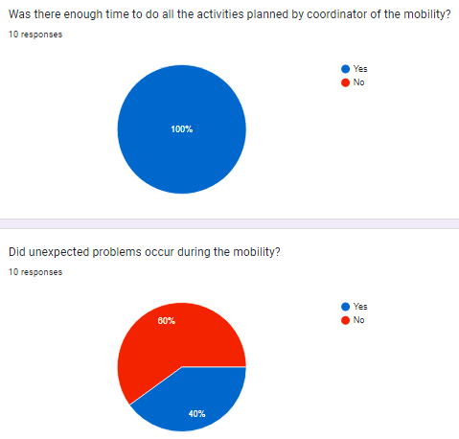
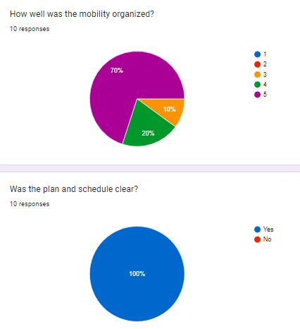

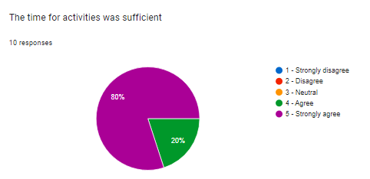
When asked about the time for activities, as well as if they were satisfied with the overall mobility in general, most of the respondents answered positively.
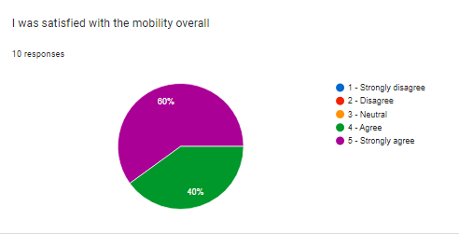

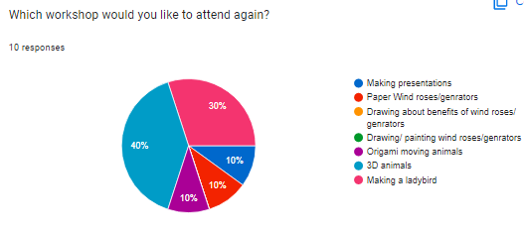
In the part where we asked them for workshops that they would like to attend again, we received the following answers:
- Making presentations: %10
- Paper Wind roses/genrators: %10
- Origami moving animals: %10
- 3D animals: %40
- Making a ladybird: %30

In the Praise / criticism section, we received the following responses:
• Workshops were very educative
• IT WAS EDUCATIONAL FOR OUR STUDENTS
• Learning about wind Roses and wind tribunes is good to understand renewable energy.
• It was an educational mobility
• We had good time
In the part where we asked them for suggestions for improving the workshops, we received no answers.
When asked to share anything they would do differently. Responses to this question are :
• Congratulations !
• Well done for the efforts!
• Great mobility
Overall impression of the mobility is positive. The only disadvantage is the difference of holiday time, and problems with internet connection. We overcame these handicaps well.
10th February 2023

Prepared by: Emine TOPDAL
(Coordinator of the Virtual Mobility in Türkiye)
Pamukören Ortaokulu - Kuyucak, TÜRKİYE

