WELCOME TO RAZGRAD, BULGARIA

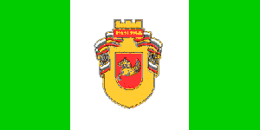

RAZGRAD HISTORY IN SOME SLIDES

Slide 1
Razgrad is a city located in Northeastern Bulgaria. It is the administrative center of Razgrad Municipality, Razgrad District. It is located in the Southern part of the historical-geographical region of Ludogorie. According to the latest NSI census as of 31.12.2019, Razgrad is the 29th largest city with a population of 30,173 inhabitants. The city of Razgrad is located in the valley of the Beli Lom river. It is located 65 km southeast of Ruse, 35 km north of Targovishte, 50 km northwest of Shumen, 130 km northwest of Varna. The international European road E70 connects it with the nearby port cities of Rousse and Varna. About 7 km from the city of Razgrad is the railway line Ruse - Varna.

Slide 6
The great devastating floods in Razgrad, of which there are memories, are four. The first is from 1821. The second heavy flood with a lot of destroyed houses was in 1897. During the flood of August 29, 1924, 48 houses were completely destroyed, and 37 were partially destroyed.

Slide 7
The flooding out in 1947 damaged 933 houses. Of these, 455 were demolished. The water invaded 165 shops, of which 17 were destroyed. The library of the community center "Razvitie" was not spared either. On an area of ​​1306.5 decares, all properties and crops were destroyed. The natural disaster also caused great losses to the trade-artisan class. The building of the Turkish junior high school "Medreseto" was taken away, 4 bridges and a large part of the city's water supply were destroyed. The damage from the flood was in the amount of 164 million levs at the time.

Slide 8
The archaeological reserve "Abritus" is located 2 km east of Razgrad, near the central road Ruse - Varna. The entire reserve covers an area of ​​1,000 acres and protects the archaeological remains of the Roman city of Abritus. Abritus was founded at the end of the 1st century AD. as a Roman military camp on the ruins of an old Thracian settlement and grew into one of the largest urban centers in Lower Moesia - the Roman province located on the territory of today's Northern Bulgaria. Ancient authors had mentioned Abritus in connection with the battle that took place in its vicinity in the year 251, in which the emperor Trajan Decius met his death. In the 4th century, a fortress was built on an area of ​​14 hectares, with a fortress wall 3 m thick and 12 m high, 4 gates and 35 battle towers. During the V-VI century, the city was an important Christian center. It was destroyed by the Avars and Slavs at the end of the 6th century. At the end of the 9th and the beginning of the 10th century, a Bulgarian fortress was built in its place.

Slide 12
The Golden Pegasus is a unique World Cultural Heritage artifact from the 4th century BC. The GOLDEN PEGASUS was discovered near the village of Vazovo, Isperih Municipality. And is an image (front, head and torso) of a galloping horse. The Pegasus figure is crafted as a three-dimensional sculpture and cast in 23.65 carat gold. The weight is 475 grams. Dating is difficult, but it is assumed to be from the 4th century BC. and that it was made in the workshops of the ancient Thracians. It was discovered by accident in 1968 near the village of Vazovo, during plowing, and was badly damaged after the discovery.It is said to have been cut in two by the tractor drivers.It was handed over to the Razgrad museum by the journalist Bakir Mustafov Kabov with two unequal fragments of the left and right wings.Much of the figure is missing.

Slide 15
Magbul Ibrahim Pasha Mosque is a Muslim temple in Razgrad, included in the UNESCO catalog, as the 3rd largest mosque in the Balkans. The construction of the prayer temple was started between 1523 and 1536 on the foundations of an earlier mosque by Bulgarian craftsmen. It was built by order of the Grand Vizier Maqbul Ibrahim Pasha. After his death in 1536, construction was stopped and the mosque was completed in 1616 by Mahmud Pasha.

Slide 16
Master Manol Monument which stands in front of the Ibrahim Pasha Mosque is included in a contemporary ensemble in the center of Razgrad.

Slide 17 Legend of the Winged Master
Sultan Suleiman the Magnificent decided to build a large and beautiful mosque which did not exist anywhere else in the world. He searched hard for a master, but not just any master, but a master of masters. It wasn't easy to find one, but he managed to find him in the end. He set him the difficult requirement that there should not be another such mosque in the world. He sent his most trustedman - Ibrahim Pasha /with whom they grew up together in the palace of the sultans/ to Razgrad. Ibrahim Pasha, together with master Manol, called Bulgarian master stonemasons from Albania. They settled not far from Razgrad and founded the village of Arnautkoi /Poroishte/. Master Manol accepted the difficult task and construction began. After the mosque was ready, by order of the Sultan, the craftsman was locked in the mosque at night, so that they could decide what to do with him. So that he did not go to another place in the Balkans and build another such mosque. The master realized that his life was in danger. He made wings out of planks, tinsel and glue-tutkal and flew early in the morning from the minaret of the mosque. The legend says that he flew to a place near Plovdiv - where a village named after him - MANOLE - was founded. Ibrahim Pasha brought water from the Bash well /the largest water source outside Razgrad/, built a hammam, a fountain, a madrasah near the mosque, and created craft workshops around it - this is how the center of Razgrad came to be. Ibrahim Pasha was sent to Ludogorie / Deliorman / with two janissary corps to pacify the disobedient Allians /Kazalbashes/, to make them pay tribute and provide soldiers for the army.

Slide 18 Legend of Razgrad's name- Hrsategrad, Hrsgrad, Hezargrad, Herazgrad – RAZGRAD
According to the tradition of local Bulgarians and Turks, it is said that near Razgrad, near the village of Vladimirovtsi, there is a medieval fortress - Kaleto. Vladimir Hrsate or (Rasate) was exiled there. Ascending the throne, he abolished Christianity and brought back the old religion - the god Tangra. His father Prince Boris I, revolted and deposed him and brought back Christianity. He exiled the blinded Hrsate to Ludogorieto /Deliorman/. He was trapped and also his followers were trapped with him. Hence the name of the Bulgarians living in Deliorman - TRAPS. Every morning Hrsate went down to a spring at the foot of the fortress to wash his eyes "Vladimir's Well", which still exists today near the ruins of the fortress. From there, the name of the village of Vladimirovtsi remained as a memory even before it fell under Ottoman rule. The village of Khrsovo has the proto-Bulgarian name Hrsate. This was the village attached to the fortress to provide food and security. The City Fortress, which is today near Razgrad, began to be called HRSATEGRAD. THIS IS TODAY'S Razgrad.

Slide 19 Church "St. Nicholas Mirlikiskii Chudtoverec" Razgrad
After the construction of the church at the end of 1860, the Razgrad princes separated from the Greek Tsarigrad Patriarchate and formed a "Bulgarian municipality".In 1873-1877, after the establishment of the Exarchate in Tsarigrad, there was a mixed Church Council in Razgrad, which attracted awake and patriot-loving citizens, public figures, teachers, writers to the city.
Slide 20
The clock tower in Razgrad dates back to 1864. It was built by the Trevna craftsman Todor Tonchev, on the foundation of an older clock tower that was destroyed due to problems in its construction. The old clock tower in Razgrad was built in the first half of the 18th century, in 1740. It dates back to 1864.
Slide 21
The fountain is one of the symbols of Razgrad. It is a cast iron sculpture of a girl dressed in antique clothes. She holds an antique water vessel on her shoulder. The fountain is believed to have been built between 1895 and 1898.

Slide 30
The Ossuary of the Russian Warriors (also called the Mausoleum) in Razgrad is located on Vazrazhdane Square. It has been a cultural monument of national importance since 1967. The monument to the Russian soldiers who died for the liberation of Razgrad was built according to the project of the Austrian architect Friedrich Grünanger, at that time the architect of Razgrad. It is 10 meters high. The foundation stone of the monument was laid on March 1, 1879 by Prince Alexander Dondukov-Korsakov – commander of the XIII Army Corps. The monument was opened on October 14, 1880. The bones of the Russian soldiers were buried in Razgrad cemetery and transferred to an ossuary in the monument in 1978.

Slide 31
The monument in honor of residents of Razgrad who died in the wars was constructed on May 6, 1995 in Razgrad. The monument represents St. George the Victorious on horseback and four commemorative granite plaques. On the plates the names of 245 people who died in the wars are written- Bulgarians, Turks, Armenians and Jews from Razgrad. Above the sculpture of St. George the Victorious is a built arch ending with a cross for bravery.

Slide 32 Ethnographic groups in Razgrad

-Bulgarians: Trappers, Hrzoi, Dobruzhians, Balkans.
-Bulgarian Mohammedans /Pomacs/.
-Turks: Sunni Turks and Alevi Turks /Kazalbashi - Bektashi and Babai/.
-Roma /Bulgarian Roma and Turkish Roma/
-Crimean Tatars.

Slide 36
PFC Ludogorets 1945 is a Bulgarian professional football club from Razgrad, current champion of the First Professional Football League.

Slide 39 Demir baba tekke
Demir baba teke is an Alevi teke with a turbe within the boundaries of the Historical and Archaeological Reserve "Sboryanovo". The Teketo (tomb) is revered by Alevi Muslims (Kazalbashi - Bektashi). They are an ethno-religious group that has its own customs and beliefs. They do not use the established Muslim ritual and revere the tombs of their saints. One of these saints is Demir Baba (Iron Father). However, there is no information about Demir baba. According to the locals, he lived in the 16th century and performed various miracles.

Slide 41
The Sveshtari Tomb is a Thracian cult complex located in Northeastern Bulgaria, Razgrad District, Isperih Municipality, 2.5 km southwest of the village of Sveshtari (Turkish: Mumjilar), 42 km northeast of Razgrad. The tomb is a UNESCO World Heritage Site. It was discovered in 1982 during the excavation of the high Ginina mound near the village. It is a Thracian-Hellenistic tomb from the first half of the 3rd century BC. This is a royal tomb where the Getic ruler Dromihet is probably buried. It is built of smoothly dressed stone blocks of soft limestone. The priest's tomb consists of a corridor and three square chambers: a vestibule, a side room and a burial chamber, covered by a semi-cylindrical vault. The entrance is decorated with columns with Ionic capitals, and above them rests a slab with a relief frieze of stylized ox heads, rosettes and garlands. The walls of the burial chamber are shaped like a colonnade with columns attached to the wall. The blocks under the arch are also supported by 10 caryatids (female figures).

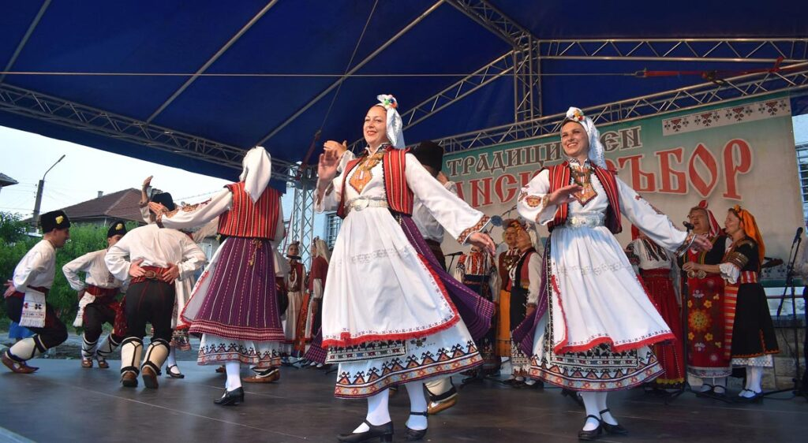

Thanks for your attention!

presented by Dimitar Petrov
/ principal of Regional library “Prof. Boyan Penev”, Razgrad, Bulgaria /

