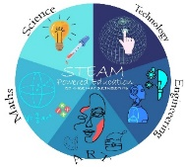

Science and Technology Club Annual Plan
2022-2023

Activity name | Date | Note
- Conductive dough | May 2022
- Electric circuits | June 2022
- Erasmus STEAM Academy | September 2022
- Electric messages | October 2022
- Spooky electric circuits | November 2022
- Building bridges | December 2022
- Who can build the strongest bridge | January 2023
- STEAM ideas | February 2023
- Green energy resources | April 2023
- Illustrations to sell products without emphasizing cultural divides | June 2023

Note* - Activities are suggested by the project partners at the start of the project and they are open to be
changed according to the available equipment and needs of the partners.

Prepared by: Kerime Husein
/Science teacher/

