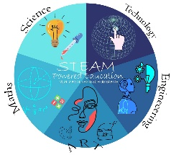
TASKS AND RESPONSIBILITIES OF PROJECT PARTNERS
Tasks | Responsibilities | Leading organisation
Project partners’ agreements preparation | - | Bulgaria
Budget plan | - | Bulgaria
Project plan and calendar | each partner | Bulgaria, Turkiye, Serbia
WhatsApp group | each partner | Serbia
Project website creation | - | Serbia
Project Facebook group | - | Bulgaria
Project Twitter, Instagram and You tube channel | - | Turkiye
Dissemination of the project activities | each partner | Bulgaria, Turkiye, Serbia
Online meetings  (zoom, skype, etc.)  organisation | each partner | Bulgaria
Science and technology social club | each partner | Bulgaria, Turkiye, Serbia
Creating Erasmus+ corners | each partner | Bulgaria, Turkiye, Serbia
Evaluation of completed tasks | each partner | Bulgaria
Establishment of the project units | each partner | Bulgaria
Creating an eTwinning project | each partner | Turkiye
“The motion of the technology” | each partner | Turkiye
“Art in everywhere” | each partner | Serbia
“Ready or not,here I come Math” | each partner | Bulgaria
“Our world is a machine” | each partner | Turkiye
“Science in the Nature” | Each partner | Serbia
Students’ observation reports | each partner
Students’ follow-up lists | each partner
Pre-questionnaires and final survey for students | each partner | Bulgaria
Interim report | each partner | Bulgaria
Erasmus+ Project Results platform | each partner | Bulgaria
Final report | each partner | Bulgaria

Prepared by: Ayten Kyazimova
/project coordinator/

